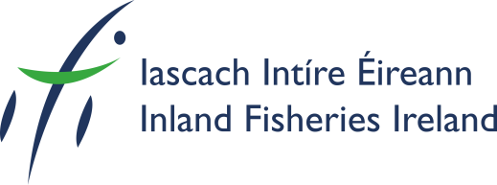

Fish Telemetry Workshop for Expert Practitioners
27th to 29th January 2015
Inland Fisheries Ireland, 3044 Lake Drive, Citywest Business Campus,
Dublin 24, Ireland
REGISTRATION FORM

TITLE AND NAME: ____________________________________________________________
NAME ON BADGE: ____________________________________________________________
ORGANISATION: _____________________________________________________________
ADDRESS: __________________________________________________________________
___________________________________________________________________________
PHONE: _______________________________________ FAX: _________________________
E-MAIL: ____________________________________________________________________
NAME OF ACCOMPANYING PERSON(S): __________________________________________

Workshop Fee: €250.00
(Payment to be made before 19th January, 2015)
This includes: - Registration
Participation in all Workshop Sessions
Lunch and Intersession refreshments /Field Trip / Workshop Dinner
Payment can be made by:
Visa / MasterCard or bank to bank transfer by contacting:
Sandra.doyle@fisheriesireland.ie

Privacy Policy: Please tick the box below if you do not wish for your contact details to be used in connection with the workshop:




