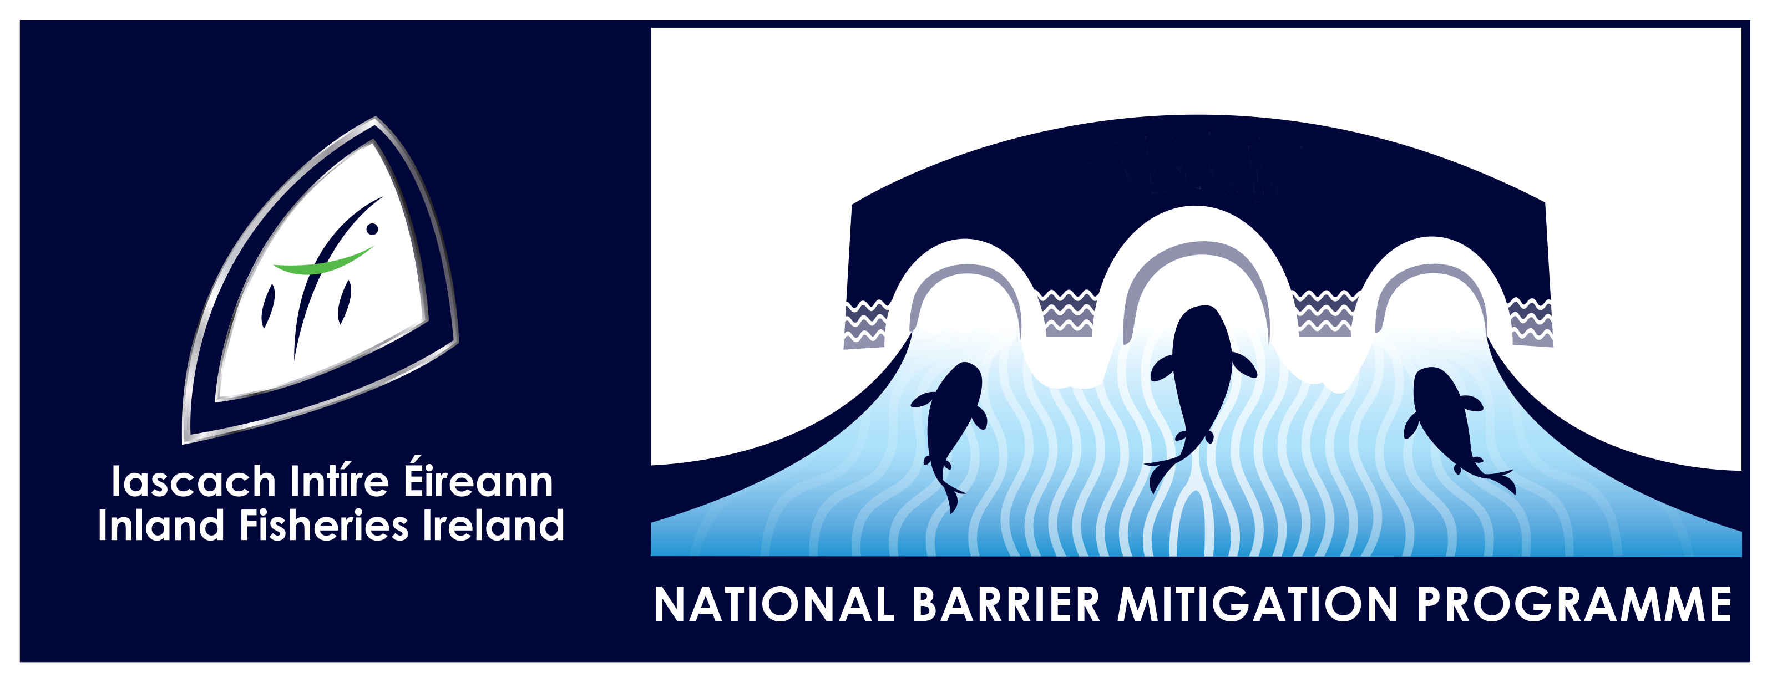

National Barrier Mitigation Programme

Barrier Mitigation Fund

Application Response Aid

Document Verification Sheet
Project Title: Barrier Mitigation Fund
Document Title: Application Response Aid
File Reference: NBMP_02.01.011.RP
Date: 13/05/2025
Issue No.: I01

Revision | Date | Description | Draft
D01 | 06/05/2025 | Prepared by |  | Checked by | Approved by
 |  | J Horan |  | M Murphy | H King
Revision | Date | Description | Issue for Fund Application
I01 | 13/05/2025 | Prepared by |  | Checked by | Approved by
 |  | J Horan |  | M Murphy | H King
Revision | Date | Description
 |  | Prepared by |  | Checked by | Approved by
Revision | Date | Description
 |  | Prepared by |  | Checked by | Approved by
Revision | Date | Description
 |  | Prepared by |  | Checked by | Approved by

Contents
1 Instructions 1
1.1 Part A – Completing the Application Response Document 1
1.2 Part B – Additional information required if the Applicant represents a State or Semi-State Agency or a Local Authority 2

Instructions

Part A – Completing the Application Response Aid
This application form is for information purposes only and is to be used as an aid to gather the critical information required to apply to the Barrier Mitigation Fund. It is not a substitute to careful reading of the scheme guidance document. This document can not be used as an expression of interest or application in its own right and all applications to the fund must be submitted via the grant management portal SMARTSIMPLE by visiting the website ifi.smartsimple.ie.

Information to be submitted by all applicants
Applicant Details
Applicant Organisation name
Applicant Contact name
Applicant job title
Email
Phone
Project Overview
Project Name/Location
Name of tributary or channel
Townland
County
GPS co-ordinates of barrier
What is the main issue that the structure resents to fish passage
Upload photos of area to include drone/ ariel photographs if available
Upload site location map
What is the primary purpose of your application? Max 250 words
Table 1 Information Required for EOI on Smart Simple by all applicants

Part B – Additional information required if the Applicant represents a State or Semi-State Agency or a Local Authority

Information to be submitted if you are part of an Organisation
LA, State Agency, Semi State
HQ Address
Partner Agencies and Stakeholders
Organisation name 1
Organisation name 2
Detailed Project Information (if known)
Background information to project to include any previous planning permission applications and previous objections
Upload site location map.
- Map to include proposed point of access for site works.
- Ownership of adjacent folios if known.
- Proposed location of site compound for works and laydown area.
Main River catchment
WFD Waterbody Code
Distance of barrier to the sea (km)
Distance from barrier to the next barrier upstream (km)
Width of channel upstream of barrier (m)
Stage Funding Required Select Option Below
Category 1: Planning Initial.
Category 2: Planning Developed and Implementation.
Table 2 Information Required for EOI on Smart Simple by if you are part of an organisation

