|  |
| --- |
|  |

**Inland Fisheries Ireland**

**Climate Action Programme**

**2019**

|  |
| --- |
|  |

|  |  |
| --- | --- |
| **Name of Document:** | IFI’s Climate Action Programme – Strategic Framework |
| **Author (s):** | Mr. Brian Beckett, Director - IFI Dublin  Mr. Pat Doherty, Head of Finance and Logistics  Mr. Thomas Mc Grory – IFI Business Development |
| **Authorised Officer:** | Dr. Ciaran Byrne, Chief Executive Officer |
| **Description of content:** | This document outlines an overview of IFI’s Climate Action Programme and recommends a framework for delivery over the coming 3 years. |
| **Approved by:** |  |
| **Date of Approval:** |  |
| **Assigned review period:** | 3 Years or as required. |
| **Date of next review:** | July 2021 |
| **Document Code:** | IFI_CLIMATEACT_Rev1_2019 |

|  |  |  |  |  |  |
| --- | --- | --- | --- | --- | --- |
| This document comprises | TOC | Text | List of tables | Table of Figures | No. Appendices |
|  |  | pages |  |  | 1 |

# Version Control Table

|  |  |  |  |  |  |
| --- | --- | --- | --- | --- | --- |
| **Version No.** | **Status** | **Author (s)** | **Reviewed By** | **Approved By** | **Date of Issue** |
| V. 02 | Draft | Brian Beckett | IFI RBDMT | Dr. Greg Forde |  |
|  |  |  |  |  |  |
|  |  |  |  |  |  |
|  |  |  |  |  |  |

# Background

*‘Warming of the climate system is unequivocal, and since the 1950s, many of the observed changes are unprecedented over decades to millennia. The atmosphere and ocean have warmed, the amounts of snow and ice have diminished, sea level has risen, and the concentration of greenhouse gases have increased’* (Intergovernmental Panel on Climate Change IPCC, 2013)

*‘…human activities are estimated to have caused approximately 1.0°C of global warming above pre-industrial levels, with a likely range of 0.8°C to 1.2°C. Global warming is likely to reach 1.5°C between 2030 and 2052 if it continues to increase at the current rate’* (IPCC, 2018)

*‘…The loss of species, ecosystems and genetic diversity is already a global and generational threat to human well-being. Protecting the invaluable contributions of nature to people will be the defining challenge of decades to come. Policies, efforts and actions - at every level - will only succeed, however, when based on the best knowledge and evidence* (Intergovernmental Panel on Biodiversity and Ecosystem Services IPBES, 2018)

As one of Ireland’s core environmental agencies, IFI is committed to leading by example in the area of climate mitigation and adaptation. IFI is seeking to consolidate our Environmental Management Systems (EMS) to help us minimise the impact on the environment resulting from IFI activities and facilities. IFI aims to work toward certification to the international standard ISO14001 in the medium term.

* 1. Climate Action in Ireland

Ireland has put in place a detailed statutory and policy framework to address both climate mitigation and adaptation. Ireland’s National Policy on Climate Change (2014) is based on the national objective of achieving a transition to a competitive, low carbon, climate resilient and environmentally sustainable economy by 2050. In terms of achieving the low carbon transition (i.e. mitigation) the policy is grounded in a long term vision of reducing emissions by at least 80% in key sectors (electricity generation, the built environment and transport) while pursuing an approach of carbon neutrality in the agriculture and land-use sector.

The 2015 *Climate Action and Low Carbon Development Act* provided a statutory basis for the preparation of the National Mitigation Plan and the National Adaptation Framework. Both are now published and will be updated over time under the 2015 Act.

* 1. National Mitigation Plan (July 2017)

Every measure and action under the National Mitigation Plan is owned by a lead Department and/or Agency. The Department of Communications, Climate Action and Environment, with technical support from the Technical Research and Modelling Group (TRAM), co-ordinate this effort. The National Mitigation Plan includes 61 measures already in place across the four sectors of electricity generation, the built environment, transport, and agriculture, land-use and forestry. A further 17 measures are identified for future decisions on implementation in the years ahead and there are additionally 106 time-bound actions. TRAM is a cross-departmental initiative which was agreed by Government in 2015 and which aims to provide a robust evidence base for informing policy choices across the climate change agenda. The outcome of this evaluation will inform decision-making on the next steps in relation to measures under consideration, and ensure an ongoing flow of additional options for consideration over time.

The National Mitigation Plan will be developed as a “living” document with a focus on achieving year-on-year progress including provision of an annual package of climate change budgetary measures. This approach will require sustained policy development, ongoing resourcing, and societal engagement – through the Citizens’ Assembly and the National Dialogue on Climate Action. In addition, the Climate Change Advisory Council was established under the 2015 Act as an independent body whose key function is to provide advice and recommendations to the Government, the Minister for Communications, Climate Action and Environment and to relevant sectoral Ministers in relation to the development of national mitigation plans and national adaptation frameworks.

The Advisory Council is also tasked with advising on matters relating to the achievement of Ireland’s objective to transition to a low carbon, climate resilient and sustainable economy by 2050. The National Mitigation Plan and reports of the Climate Change Advisory Council can be found [HERE](https://share.fisheriesireland.ie/Operations/ClimateActionProgramme/_layouts/15/start.aspx#/) in IFI SharePoint.

1.3 National Adaptation Framework (October 2017)

Notwithstanding climate change mitigation, we must also consider how we are going to adapt to climate change. We know that changes will increase in the coming decades (i.e. climate change that is already locked in by virtue of global emissions to date), and this will result in significant impacts which will require adaptation responses. Climate change will have diverse and wide ranging impacts on Ireland, including managed and natural ecosystems, water resources, agriculture and food security, human health, and coastal infrastructures and zones.

The 2015 Act requires the National Adaptation Framework to set the strategy to reduce the vulnerability of the State to the negative effects of climate change and avail of any positive effects that may occur. The first statutory National Adaptation Framework was published in early 2018.

The National Adaptation Framework aims to:

• provide the policy context for a strategic adaptation response, at all levels, to climate change;

• integrate adaptation considerations into all relevant policy areas;

• promote dialogue and understanding of adaptation issues;

• identify sectors for adaptation actions and lay out a high level vision for how these sectoral adaptation plans and local/regional adaptation strategies should be prepared and the principles that they should cover; and

• commit to actions to support and coordinate the adaptation process, including research and governance.

The National Adaptation Framework can be found [HERE](https://share.fisheriesireland.ie/Operations/ClimateActionProgramme/_layouts/15/start.aspx#/) in IFI SharePoint.

1.4 Climate Change in Ireland: Projected

Climate impacts – 2050 and beyond

* Temperature: mean annual temperatures will increase by 0.90-1.7°C, with the largest increases seen in the east of the country.
* Hot days (defined as top 5% of maximum daily summer temperature) will get warmer by 0.7-2.6°C compared with the baseline period.
* Cold nights (defined as bottom 5% of minimum daily winter temperature) will get warmer by 1.1-3.1°C.
* Frost days averaged over the whole country, the number of frost days (defined as a day when the minimum temperature is less than 0°C) is projected to decrease by over 50%.
* Growing season: the average length of the growing season18 will increase by over 35 days per year (Nolan, 2015).
* Precipitation: results show significant projected decreases in mean annual, spring and summer precipitation amounts by mid-century. The projected decreases are largest for summer, with reductions ranging from 0% to 20%.
* Heavy rainfall events will increase in winter and autumn (Nolan, 2015).
* Wind and extreme events: the energy content of the wind is projected to decrease during spring, summer and autumn. The projected decreases are largest for summer, with values ranging from 3% to 15% (Nolan, 2015).
* Storms affecting Ireland will decrease in frequency, but increase in intensity, with increased risk of damage (Nolan, 2015).
* Surface water (rivers and lakes) and runoff: Intensification of the
* hydrological cycle, leading to both increased incidences of high and low flow periods (Murphy, Harrigan, Hall & Wilby, 2013).
* Sea level rise: rise of c.55-60cm to 2100 (based on medium scale climate warming scenarios, viz. (Dunne et al., 2008; Lowe et al., 2009). Changes in mean sea level predicted will be the primary driver in magnifying the impacts of changing storm surge and wave patterns in coastal areas.
* Regional sea level rise, (allowing for isostatic components), of c.25cm (Dublin/east coast Ireland), c.44cm Sligo/central western coasts, c.40cm south west Ireland by c.2080-2100 (Devoy, 2008)

The above observations confirm that Ireland’s climate is changing in terms of sea level rise, increases in average temperature, changes in precipitation patterns, and weather extremes. These changes are projected to continue and increase over the coming decades (Gleeson et al, 2013; Nolan, 2015) and projected changes include: temperature rise, changes in the frequency

and intensity of extreme weather events; increased flows to river catchments; ongoing sea level rise; and changes in precipitation patterns and regimes. These changes, in turn, will impact on a number of key socio, economic and environmental sectors in different ways which will require appropriate and relevant sectoral responses within the context of this Framework. Examples of such impacts are provided in National Adaptation Framework - Page 29, Box 1. Of particular relevance are negative sectoral impacts summarised for Biodiversity, Marine and Fisheries and Water Management as follows:

**Biodiversity:** Ireland’s natural landscape is one of its greatest assets and climate change is expected to have significant impacts and exacerbate existing pressures. Increasing temperatures will impact on the geographical range and phenology (the timing of lifecycle events) of native species. Projected shifts in climate, temperature and precipitation, may result in the increased occurrence of invasive species and competitive pressures for Ireland’s native species.

**Marine and fisheries:** Projected changes in sea level, coastal flooding and erosion, and physicochemical changes in the marine environment will have wide-ranging implications for the Marine and Fisheries sector. For example, increased sea surface temperatures will affect the biogeographical ranges of species distribution including major commercial fish stocks. There will likely be a reduction in the range of some northerly species, while southerly species are likely to increase their range northward. Warmer waters support

lower levels of dissolved oxygen and provide favourable conditions for the growth of algal blooms.

**Water management:** Climate change will pose significant risks to water management and will exacerbate existing pressures in terms of water supply, quality and flooding. For summer and autumn, projected decreases in surface water flows and increased levels of evapotranspiration will mean a decrease in levels of available water resources and this may lead to problems of water supply.

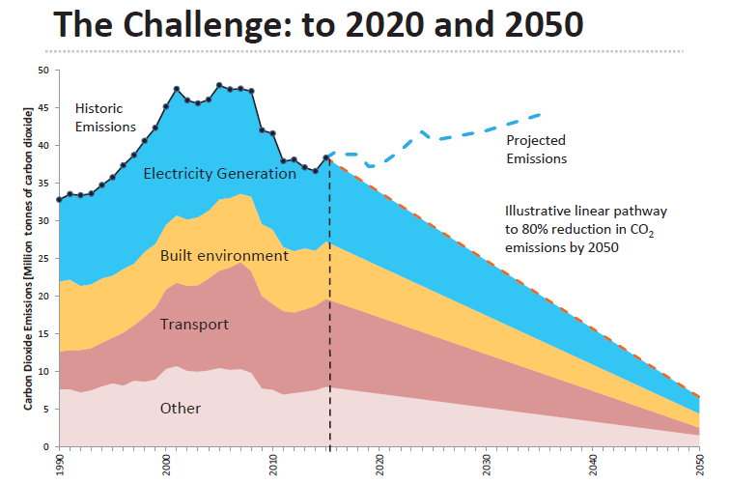

# Strategic Framework for Climate Action - IFI Business Plan 2018

* 1. Leadership and Ambition

As outlined in the *Strategic Framework for Public Sector Energy Efficiency* (DCCAE, 2017), the public sector can and should take a leadership role in embedding energy efficient technologies and behaviours in Ireland, developing the energy efficiency supply chain and creating opportunities for indigenous enterprise and innovation. Achieving the transition to a low carbon economy requires that we all use energy more carefully. There is a very real expectation among business and local communities that citizens should be able to look to their public organisations for leadership in this transition, in particular, on energy efficiency. The importance of public sector energy efficiency to wider public sector reform, and citizen engagement in the low carbon transition, has shaped the objectives of the strategy as follows:

* The public sector, maximising its own skills and experience, takes a national leadership role in deploying cost efficient energy efficiency projects and initiatives
* The delivery of this Strategy is a shared, whole of Government, effort where all Government Departments, and the bodies under their aegis, play their part in embedding structured energy management as part of their business delivery
* In the context of public sector reform, the public sector takes an action focused and results driven approach to sustainable and cost efficient energy management, thereby delivering better value for money and better services for citizens
* The public sector contributes to the development of a more sustainable energy system, a reduction in our CO2 emissions and a cleaner healthier environment now and for future generations
  1. IFI Business Plan - 2018

With ambition to deliver in the context of the Strategic Framework for Public Sector Energy Efficiency, the National Mitigation and Adaptation Plans, IFI has identified a number of actions and outputs under the strategic heading of ‘Climate Action Programme’ in the 2018 IFI Business Plan. IFI intends to implement this item broadly under two sub-items as outlined below.

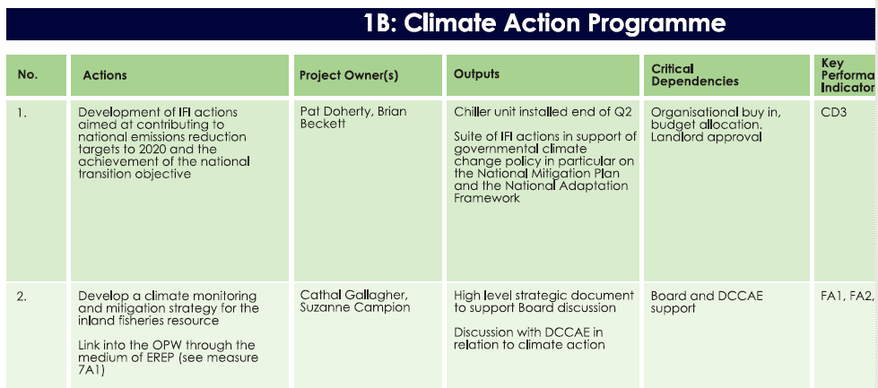

Action 1: Development of IFI actions aimed at contributing to national emission and energy reduction targets to 2020 and the achievement of the national transition objective.

2.2.1 Environmental Management Programme (EMP)

IFI intends to address the environmental impact of our activities through ongoing development of IFI’s current Environmental Management System (EMS) activities in order to deliver:

* Improved energy efficiency through energy auditing and subsequent action;
* Reduced generation and improved management of wastes, emissions, effluents;
* Conservation of natural resources where possible;
* Efficient operation with associated cost savings;
* Environmental / climate action initiatives that are aligned with the strategic aims of IFI.

IFI will form a national ‘EMS Team’ to implement the requirements of the EMS through a national Environmental Management Programme (EMP) and will annually identify aspects of IFI’s operations that impact, or have the potential to impact, the environment. The relative significance of these aspects will be recorded and objectives will be set and mitigations will be put in place to reduce their potential impact on the environment. The significant aspects for reporting and action here will include:

2.2.2 Energy

A structured approach to energy management will make environmental and financial sense for IFI. The importance of mapping and understanding IFI energy use to make sure that the energy efficiency projects undertaken are based on sound data and tailored to our needs cannot be overstated. Energy will be used more efficiently if the conditions to enable that more efficient use are first created. If a facility or process is designed to function in an energy efficient way, or the most energy efficient equipment is acquired, then the gains in terms of energy savings and CO2 emission reduction at the end use point will be maximised. Based on best practice and practical experience from many programmes such as the International Standards Organisation (ISO) 50001 energy management standard, the Irish Standard IS 399 (Energy Efficient Design Management), the Sustainable Authority of Ireland (SEAI) Energy MAP training programme and the SEAI Sustainable Energy Communities Scheme, IFI will, as a minimum, practice these 5 basic, structured energy management steps:

1. Commit: IFI signed up to a partnership agreement with SEAI in 2017. IFI have appointed a senior manager in IFI to provide leadership and accountability; Empower IFI staff to act: choose an appropriate path to energy management or certification.
2. Identify: work to identify actions and projects based on IFI energy performance data – SEAI and OPW can assist.
3. Plan: avail of strategic planning assistance through IFI’s partnership agreement with SEAI; build energy management capacity; integrate facilities management, finance and human resource functions in IFI’s energy management planning; set annual energy saving targets.
4. Take Action: avail of project design, development and supervision support; commit to projects.
5. Review: measure results through in-house systems and SEAI’s energy portal monthly and continually improve energy performance.

Energy Performance Officer (EPO)

All public sector bodies must designate an Energy Performance Officer (EPO) from among their senior management team. In order to be accountable for energy management and performance, the EPO should have decision making powers with regard to facilities management, corporate budgets and procurement, along with responsibility for corporate and financial reporting, so that they can:

* Lead the development of their organisation’s Energy Management Plan as an integral part of their organisation’s Business Planning and Performance Management processes
* Drive the implementation of the actions and projects agreed under the Energy Management Plan
* Assign clear responsibility for implementation of the Energy Management Plan and ensure staff have the necessary training and support to carry out these tasks
* Ensure the setting of annual energy saving targets for their organisation
* Ensure the timeliness and quality of their organisation’s annual data reports to the SEAI Public Sector Energy Performance Monitoring & Reporting System
* Ensure timely provision of their organisation’s report for the Annual Memorandum to Government on the implementation of this Strategy
* Include these tasks as part of annual goal setting under PMDS

Making energy efficiency the norm is ultimately dependent on changing mind-sets and behaviours. IFI management must optimise the conditions for efficient use of energy by their teams. This will build evidence for IFI team members that their actions make a difference, and that energy efficiency makes good business sense.

IFI’s Energy Efficiency and Reduction in CO2 Emissions

IFI’s ‘Carbon Footprint’ relates both to direct and indirect greenhouse gas (GHG) emissions. Direct GHGs are generated from sources that are owned or controlled by the organisation - for example these would include emissions from combustion in transport and natural gas fired boilers in property management. Indirect GHG emissions occur as a result of the generation of purchased electricity consumed by the organisation (i.e. emissions due to electricity generation).

The National Energy Efficiency Action Plan sets a target for the public sector to improve its energy efficiency by 33% with a deadline of 2020. The Public Sector is expected to play an increasingly high profile leadership role in the areas of energy efficiency and carbon emissions reduction not to mention in the broader area of climate action. All public bodies are required to report detailed energy data on an annual basis using the SEAI online Monitoring & Reporting (M&R) System. These data are used to track progress towards the 2020 energy efficiency reduction target of 33%.

IFI have selected 2009 as the baseline year from which to track overall energy reduction progress and the energy performance indicator [Primary Energy kWh / Full Time Equivalent Employees (FTEs)] to track progress for each reporting year to 2020. The overall energy efficiency saving as of 2017 for IFI is 17% since the baseline year in 2009.

The SEAI manages the public sector programme for energy reduction and supports the public sector in meeting this target. The supports offered are onsite energy assessments, energy efficient design assistance, energy project implementation, a dedicated energy advisor, energy reporting advice and best practice guidance and networking. As part of this process, the SEAI developed an Energy Performance Indicator (EnPI) to guide public sector organisations towards the 2020 targets. The SEAI’s ‘Annual Report 2017 on Public Sector Energy Efficiency Performance’ rated IFI’s overall status in terms of energy efficiency as ‘*14.9% better than 2016 and 17.2% better than our 2009 baseline…more efficient than 2016 baseline, but not yet on the path for meeting the 33% energy reduction by 2020 target*’. Modernisation of IFI’s fleet and the introduction of findings from energy audits will see IFI achieve its 33% energy reduction target by 2020. An accelerated programme of measures is planned to influence the use of energy in IFI with the goal of not only meeting but exceeding IFI’s 2020 targets as follows:

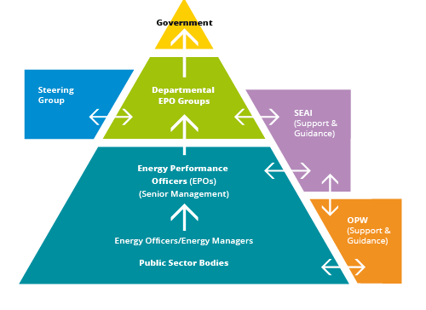

ENERGY (Properties)

Design: when new facilities and processes are being planned and designed and when existing facilities and processes are being re-designed

Acquisition: when vehicles, equipment and facilities are being bought, upgraded or leased

Use: when IFI staff use energy in the course of their work

Building and Process Design: The greatest opportunity to reduce lifecycle energy and carbon for IFI is at the early design stages of new investments. SEAI advise that up to 95% of the lifespan cost is already committed at the end of the design process and that case studies have demonstrated that savings available can range up to 50% improvement from a baseline design. The SEAI’s Annual Report 2016 on Public Sector Efficiency Performance found that electrical accounted for 51% and heating (thermal) accounted for 25% of primary energy consumption in the public sector.

National Standards and Certification: IS (Irish Standard) 399 is a standard developed by the SEAI and the National Standards Authority of Ireland (NSAI) to allow organisations to develop and continuously improve their capacity in energy efficient design management. The short time-bound period of design provides the greatest energy saving potential with the most attractive return on investment. Coupled with the ExEED Certified Energy Efficient Design Programme launched as a pilot by SEAI in April 2016, the standard provides a mechanism to certify Energy Efficient Assets. The certification is based on full life cycle, verifiable energy savings, fully compatible with other IS and ISO standards and fully independent, compliance based, audit. The standard is applicable to any scale of facility, new build or building renovation and creation or re-design of equipment and processes.

Building renovation: The SEAI report, *Unlocking the Energy Efficiency Opportunity* published June 2015, identified the technical potential for energy savings of 2,500 GWh in public buildings to 2020. The report went on to analyse how much of this technical potential it would be cost effective to realise. It found that ‘deep’ measures i.e. those that technically could produce the largest amount of energy savings such as, solid wall insulation, window replacement and heat pumps, were often not cost effective when installed on their own because the pay-back periods are too long. However, when installed as part of a ‘package’ of measures, including ‘shallower’ measures with shorter pay-back periods such as lighting and heating upgrades (both to include controls and roof insulation), then these deeper measures become relatively more cost effective and could provide 1,600 GWh of energy savings. This technical and economic analysis shows that it is the combination of shallow and deep measures that will achieve increased, and more durable, energy savings and better value for money.

In practical terms, the approach should be to exploit the short pay back works first (e.g. behaviour change, optimising existing controls, and mechanical and electrical upgrades). The next step is to consider those projects with longer payback and identify synergies between these work packages.

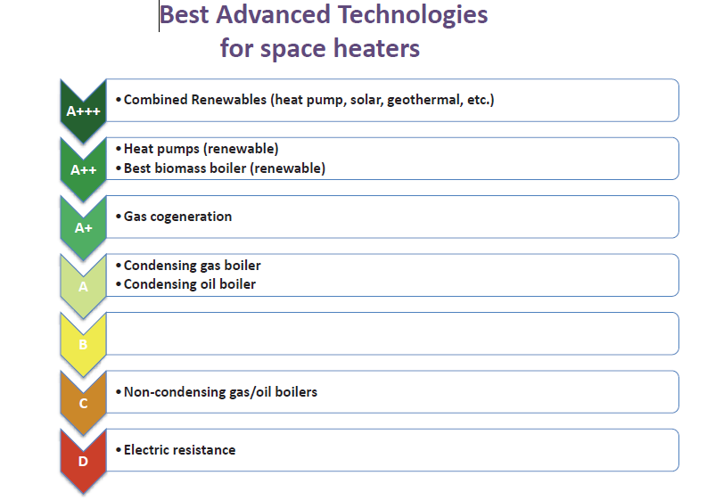

Renewables and energy sustainability: IFI should adopt renewable energy solutions in tandem with energy efficiency action where appropriate. Use of renewable energy is rewarded in the methodology used to track public bodies energy performance (SEAI’s Monitoring and Reporting system). Onsite renewable energy generation that offsets imported grid electricity will improve IFI’s energy performance. A holistic approach to energy saving projects and improved energy performance is planned. The strategy to improving energy sustainability is as follows:

1. Energy management: understand your existing energy use, and adopt ongoing controls

2. Energy efficiency: through onsite surveys identify energy efficiency improvements to facilities, vehicles and equipment to reduce that usage

3. Renewable technologies: examine renewable options when considering how to meet this reduced energy use

Energy (Transport)

The SEAI’s Annual Report 2016 on Public Sector Efficiency Performance found that transport accounted for 23% of primary energy consumption in the public sector in 2016. Therefore public sector transport fleets account for a very significant proportion of expenditure, and emissions, in the public sector. As an area spanning the public sector, better transport energy management through actions, such as ensuring energy efficiency criteria are a priority in fleet replacement can deliver real financial savings and make an important contribution to reducing CO2 emissions.

It makes sound energy management, and financial, sense for public bodies with large transport fleets (either operational vehicles or public transport) to make energy efficiency central to their fleet management. Therefore, public sector bodies with fleets of 10 vehicles or more should undertake a transport specific energy audit as part of their wider energy management planning process. They should also undertake a vehicle life span cost analysis as part of the requirement on them to produce an annual Energy Management Plan to ensure that appropriate vehicles are matched to task in the public fleet. Relevant public bodies are required to publish the findings of their analysis in their Annual Report and ensure that these results inform procurement of new fleet. Public sector service fleets (excluding school transport), travelling more than 5000 km per year should have a telematics or tracking system fitted to optimise journeys and eliminate unnecessary journeys.

Efficient driving behaviour has been shown to improve transport fuel efficiency by between 5% and 10%. Many public sector bodies with transport fleets already provide ‘Eco-driving’ training for their employees and have driver management processes in place. Advice on how to do this is available from the SEAI. Other innovative measures to improve efficiency in, and reduce emissions from, public sector fleets will be identified in consultation with key public sector bodies and stakeholders, primarily through accelerating the introduction of more energy efficient and alternative fuelled vehicles across the public sector. The National Transport Authority (NTA) and DTTAS will also consider options for improving efficiency in the publicly funded public transport fleets including potential investment in new engine technologies and driver advisory systems.

The public sector can influence energy usage through developing Workplace Travel Plans (WTPs) with support, as required, from the NTA. A WTP is a package of measures aimed at supporting sustainable travel for work-related journeys. It comprises actions to promote walking, cycling, public transport, car-sharing, modal shift, the use of technology instead of travel, and flexible working practices. It has been recommended by DCCAE (Public Sector Energy Efficiency Strategy) that all public sector bodies develop a WTP and establish a review mechanism. The emphasis in WTP’s on physical exercise is a good example of how energy efficiency could link with Government objectives to improve public health and wellbeing such as the Healthy Ireland Initiative.

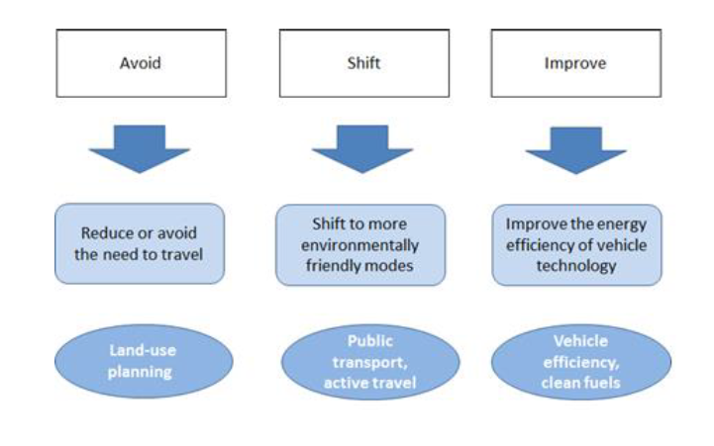

Water and Waste

The processes around the collection and treatment of water and wastewater make this service one of the most energy intensive in the public sector. A full audit of IFI facilities will seek to further map current water / waste energy and practices and develop and apply a range of improvement measures in conjunction with the EMS team to reduce IFI’s environmental footprint.

**IFI ENVIRONMENTAL MANAGEMENT SYSTEMS & PROGRAMME – NOW and NEXT STEPS**

|  | Current Situation | Next steps |
| --- | --- | --- |
| ENERGY / Buildings | Primary energy sources throughout IFI are ELECTRICITY and NATURAL GAS. Electricity is used for lighting, power and air conditioning. Natural gas, LPG, and kerosene are used primarily for space heating. Monitoring and reporting of energy consumption takes place across IFI sites. Occupancy sensors and intelligent lighting systems have been introduced to reduce consumption in some locations. | * Enhanced coordination through formation of national EMS team, designate EPO. * Appoint Energy Performance Officer in line with Public Sector Energy Strategy. * Identify projects & actions based on energy monitoring data across all locations (shallow and then deep measures) including solar thermal and PV, energy efficient windows, doors, cavity wall insulation, roof insulation, energy efficient heating systems. * Install intelligent lighting systems in all IFI public buildings / convert light fittings to LED where possible. * Set Energy reduction targets across all locations. * Monitor & report on energy performance - all locations. * Explore IS399 & ExEED initiatives |
| ENERGY / Transport | **The majority of IFI staff comprise IFI’s ‘mobile workforce’ travelling on a daily basis to deliver IFI’s functions, including: law enforcement / protection, conservation, site visits, inspections and environmental monitoring on a nation-wide basis. Staff attend meetings both nationally and internationally. Many IFI sites are outside urban areas where public transport options are limited. By necessity, IFI’s fleet (approximately 200 vehicles) are working vehicles. IFI has tested alternative fuels in its fleet however early adoption and associated limited fuel options means that IFI’s current fleet is almost entirely powered by fossil fuels. IFI has made significant changes in the area of fleet management over the recent period including:**   * **Procurement of national fleet servicing contract to maximise environmental benefit** * **Introduction of telematics system** * **Rationalisation of vehicle types** | * **Enhanced coordination through formation of national EMS team, designate EPO.** * **Board commitment to decarbonisation of IFI Fleet** * **Rationalising the fleet to remove carbon-intensive vehicles, replacing end-of life fleet vehicles with low- or zero-emission variants; including Green Public Procurement criteria in the purchase, or lease, of new vehicles and/or maintenance contracts.** * **Continue to measure, monitor and report CO2 emissions** **on Km's travelled, fuel usage etc.** * **Training for staff on the optimal use of PHEVs when ‘on fleet’, ‘eco-driving’ training** * **Set targets for annual improvements in the overall IFI transport emissions profile.** * **Provide a significant increase in the number of vehicle charging points at IFI sites** |
| WATER & WASTE | IFI strives to conserve and protect valuable water resources as a core component of IFI’s remit. Waste initiatives have not been coordinated throughout the country. Targeted actions are inconsistently employed throughout the country at IFI properties however a number of initiatives have been developed including greywater harvesting, paper recycling, etc…. | * Enhanced coordination through formation of national EMS team, designate EPO * Water conservation / waste management measures at each IFI site to include: * Green bins paper recycling system for all IFI offices * Rainwater harvesting for all IFI sites * Greywater re-use systems roll-out * Wastewater systems upgrades / maintenance contracts review and renewal * Removal of single use plastics * Distribution of IFI reusable cups to all staff * Information campaigns |

WHAT IF…..



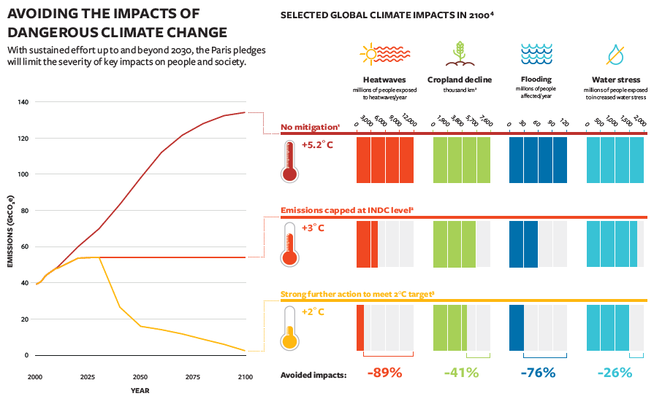

Figure . Avoiding the impacts of dangerous climate change *(Source: AVOID2 infographic mapping the impacts of climate change, December 2015)*

Action 2. Develop a climate monitoring and mitigation strategy for the Inland Fisheries Resource.

ADDITIONAL CONTENT…